LAB Manual

| **Name of Student : Parimal Kulkarni PRN:22070122138** |
| --- |
| **Semester : IV Year AY 23-24** |
| **Subject Title: Operating Systems Lab** |
| **EXPERIMENT No : 4 Assignment No: 5** |
| **TITLE : Arithmetic Operations DoP :31/01/2024** |

***Aim:*** Implement and demonstrate arithmetic operations

***Learning Outcomes:*** *1. To understand the arithmetic operation*

*2. To Demonstrate the arithmetic operations using Linux command.*

***Hardware/Software*: (to be handwritten)**

Problem Definition:

A program should be written where all the following conditions should be satisfied.

1. Perform basic operations like Addition, Subtraction, Multiplication, and Division. Accept input from a user.

2. Calculate the area and perimeter of the circle. Accept radius from a user. (Assume pi=3.14)

3. Calculate employees’ gross salary, where DA is 1.65% of the basic salary, and HRA is 0.30% of the basic salary. Accept the value of basic salary from a user.

4. Calculate the mean salary given by a company if the basic salary of employees A, B, C, and D are Rs.1200, 1400, 1350, and 1800 respectively.

***Theory:*** handwritten

***Algorithm :*** softcopy format

***Program***: Softcopy format

Without using floating point:

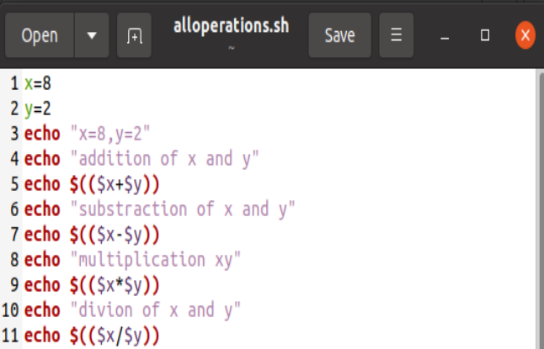

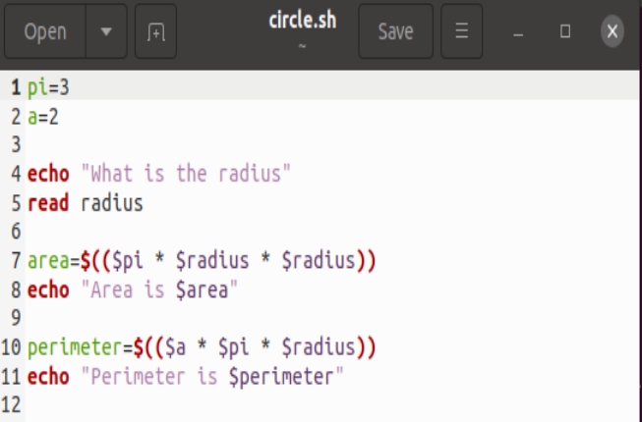

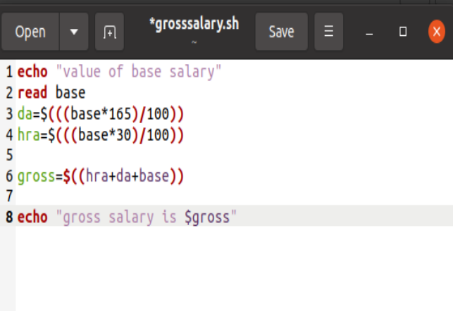

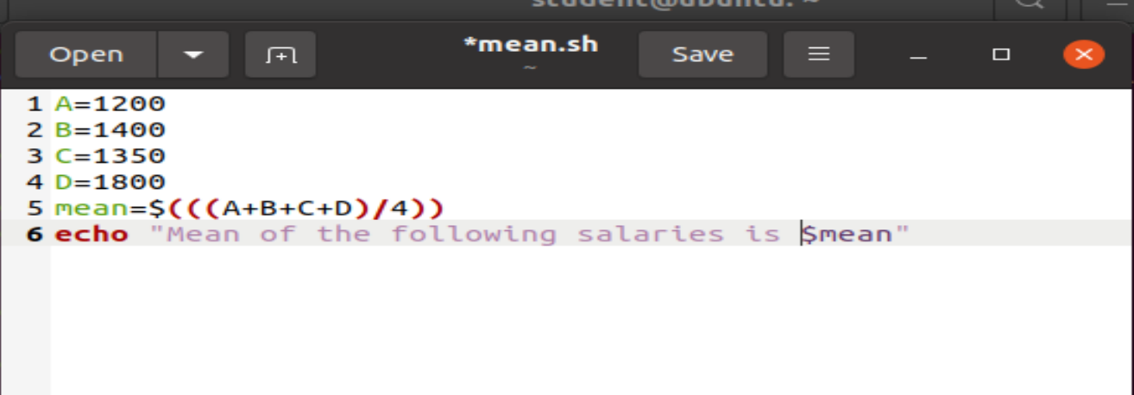

***Using Floating Point:***

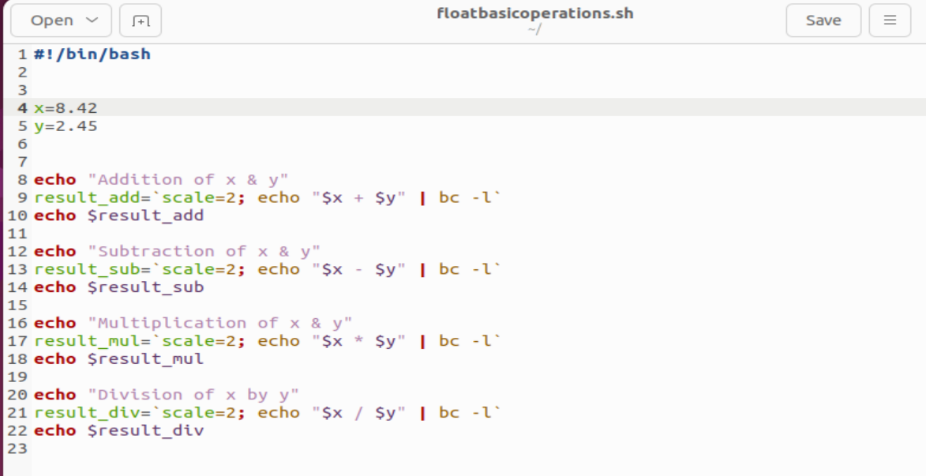

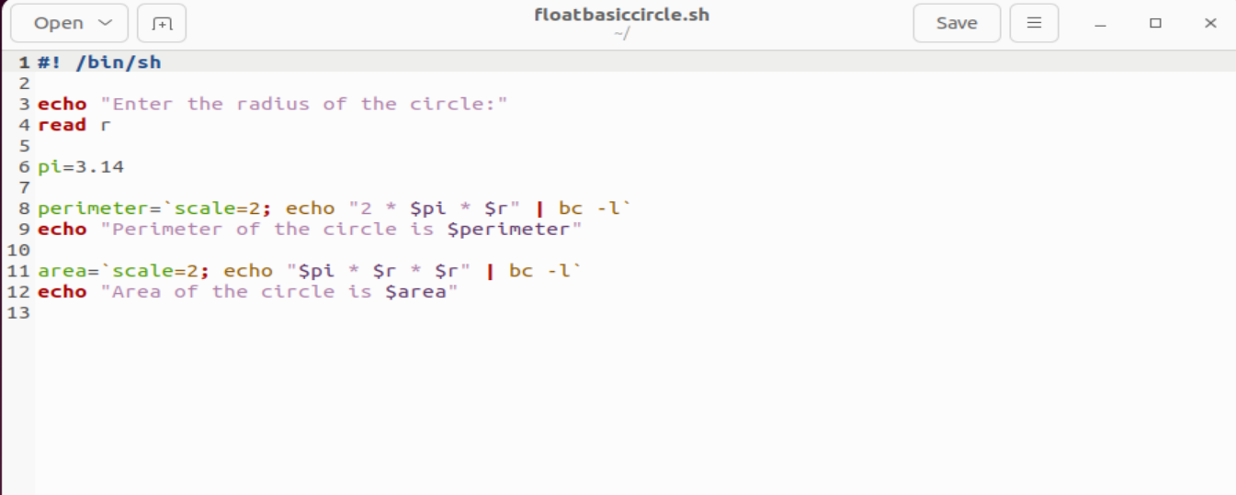

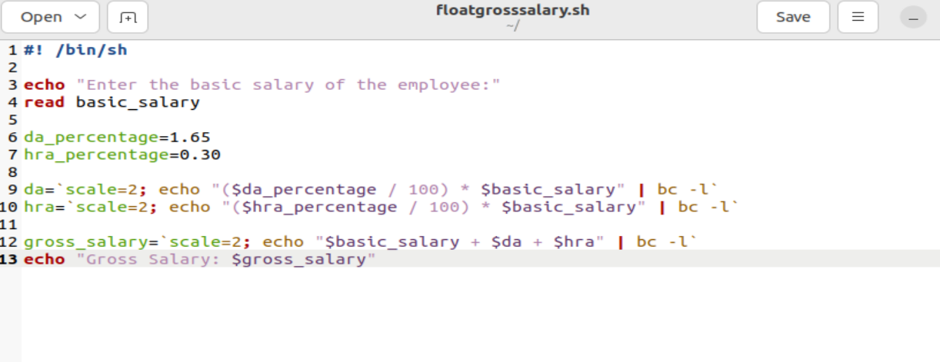

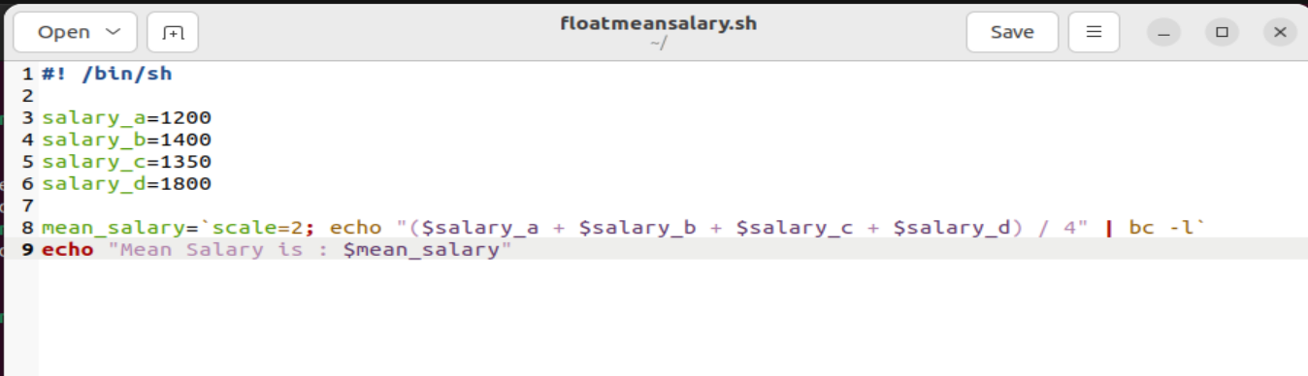

***Steps to execute the program:*** handwritten

***Conclusion:*** Handwritten

***Output:*** snapshots of the demonstration

Without using floating point output:

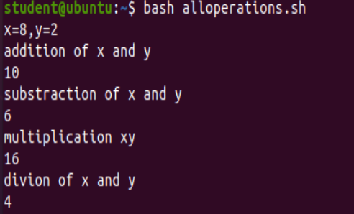

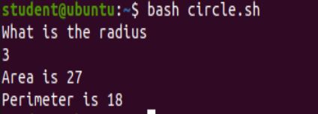

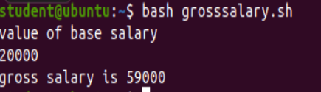

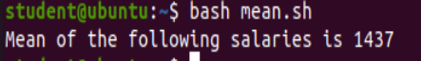

floating point operations output:

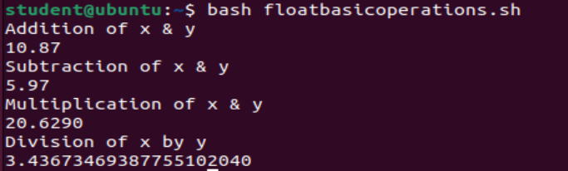

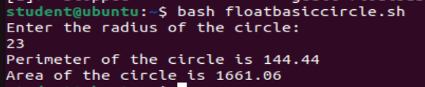

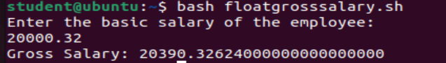



| Attendance | Discipline | Short oral | Correctness of Lab Report | Timely completion of Lab Report | Total marks  (10) | Signature of Teacher with Date |
| --- | --- | --- | --- | --- | --- | --- |
|  |  |  |  |  |  |  |

``